Name: ________________________________________ Date: _________

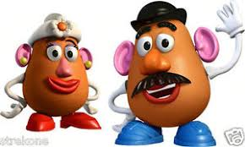

“Let’s FACE It!”

*Mr. and Mrs. Potato Head Punnett Squares Activity*

**Background:** In the species *Potato headius*, all characteristics are genetic, meaning they inherit those qualities from their parents. You and your partner will create either MR. Potato Head OR MRS. Potato head, while the set of partners across from you will create the opposite. This means that at the end, your group of 4 will have BOTH a MR. & MRS. Potato Head! In the second part of the activity, you will create the Punnett Squares based on their Genotypes and predict what their future offspring could look like! Good Luck and Have Fun in making your Potato creations!

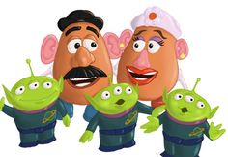Your Final Product Includes (Per Group of 4)

* A Mr. Potato Head
* A Mrs. Potato Head
* A baby Potato Head

Materials Needed (per group of 4):

* 3x Potatoes
* 3x A COLORED Copy of Potato Head Pieces
* Tape
* 4x coins

My Name: _________________________/ My Partner’s Name: _____________________

2 Partners sitting across from us: ____________________ & ______________________

Among the 4 of you, decide the following:

Me and My partner will build the: MR. MRS. (Circle One)

2 Partners sitting across from us will build the: MR. MRS. (Circle one and make sure it is the opposite!)

*Great, now we are ready to go!...*

**Procedure:**

Use your coin to flip for traits. You and your partner EACH need to flip a coin. At the end of each flip you will have ONE of THREE possibilities as follows:

**2 Heads = Homozygous Dominant**

**1 Head/ 1 Tail = Heterozygous**

**2 Tails = Homozygous Recessive**

For each trait, CIRCLE your results in the “Traits Table.”

**Traits Table**

|  |  |  |  |
| --- | --- | --- | --- |
| **Trait** | **Homozygous Dominant** | **Heterozygous** | **Homozygous Recessive** |
| Hat Shape | Pirate Scarf  HH | Fire Hat  Hh | Cop Hat  hh |
| Feet | Blue Shoes  FF | Sandals  Ff | Yellow Bow Shoes  Ff |
| Nose | Pink Oval Nose  NN | Tan Nose  Nn | Round Red Nose  nn |
| (Male Only) Mustache | Mustache Present  MM | Mustache Present  Mm | Mustache Absent  mm |
| Ears | Pink Ears  EE | Pink Ears  Ee | No Ears, but has wings  ee |
| Mouth Color | Mouth with Teeth  MM | Mouth with Teeth  Mm | Brown Mouth  Mm |
| Arm Color | White Arms  AA | White Arms  Aa | Red Arms  aa |
| Eye Color | Black Eyes  BB | Eyes with Patch  Bb | Blue Eyes  Bb |
| Glasses | No Glasses  GG | Green Glasses  Gg | Red Glasses  gg |
| (Female Only) Accessories | Purse  AA | Flower  Aa | Umbrella  aa |

**Your Results Table:**

Based on your Results above, fill in the Data Table below for your Potato.

|  |  |  |
| --- | --- | --- |
| **Trait** | **Genotype** | **Phenotype** |
| Hat Shape |  |  |
| Feet |  |  |
| Nose |  |  |
| (Male Only) Mustache |  |  |
| Ears |  |  |
| Mouth Color |  |  |
| Arm Color |  |  |
| Eye Color |  |  |
| Glasses |  |  |
| (Female Only) Accessories |  |  |

This Data Table is for _______MR. _________ MRS. (Check One)

**“The 2 Partners Across from You” Results Table:**

**EXCHANGE DATA!** Based on the results of the partners across from you, fill in the Data Table below.

|  |  |  |
| --- | --- | --- |
| **Trait** | **Genotype** | **Phenotype** |
| Hat Shape |  |  |
| Feet |  |  |
| Nose |  |  |
| (Male Only) Mustache |  |  |
| Ears |  |  |
| Mouth Color |  |  |
| Arm Color |  |  |
| Eye Color |  |  |
| Glasses |  |  |
| (Female Only) Accessories |  |  |

This Data Table is for _______MR. _________ MRS. (Check One)

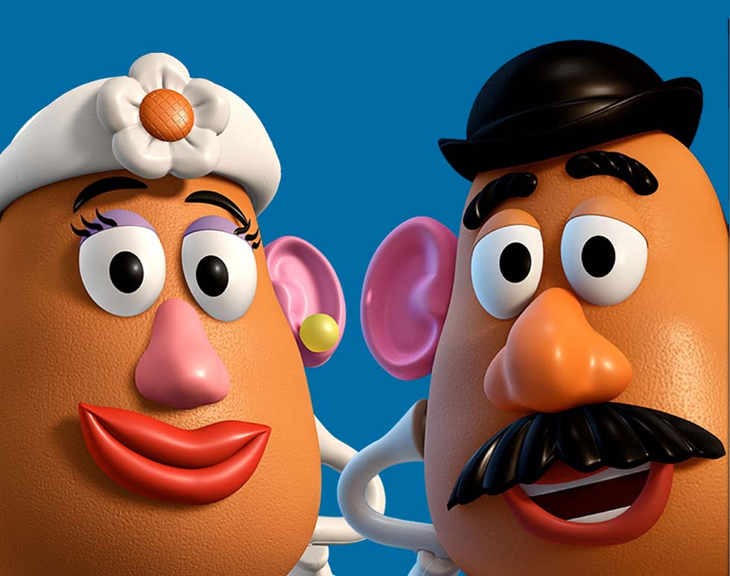

Now, get 2 people from your group to construct your Mr. and Mrs. Potato heads using the Pieces and Potatoes. While the other two create the “baby” Potato Head

**Baby Potato Head**

Use the same table to determine the traits table from the start to determine the traits of Baby Potato Head.

#1 Determines the sex of the Potato Head Baby. Females (XX) can only donate an X sex chromosome, males (XY) can donate an X or a Y. Therefore, the father will flip the coin to determine the sex of the baby. (Heads = Girl: gives X allele. Tails = Boy: gives Y chromosome).

**Baby: Traits Table**

|  |  |  |  |  |
| --- | --- | --- | --- | --- |
| Trait | Mother’s genes | Father’s genes | Punnett Square (if needed flip coin(s) then circle Genotype | Phenotype |
| 1. Sex of baby |  |  | |  |  | | --- | --- | |  |  | |  |  | |  |
| 2. Hat shape |  |  | |  |  | | --- | --- | |  |  | |  |  | |  |
| 3. Feet |  |  | |  |  | | --- | --- | |  |  | |  |  | |  |
| 4. Nose |  |  | |  |  | | --- | --- | |  |  | |  |  | |  |
| 5. Mustache (male only) |  |  | |  |  | | --- | --- | |  |  | |  |  | |  |
| 6. Ears |  |  | |  |  | | --- | --- | |  |  | |  |  | |  |
| Trait | Mother’s genes | Father’s genes | Punnett Square (if needed flip coin(s) then circle Genotype | Phenotype |
| 7. Mouth colour |  |  | |  |  | | --- | --- | |  |  | |  |  | |  |
| 8. Arm colour |  |  | |  |  | | --- | --- | |  |  | |  |  | |  |
| 9. Eye colour |  |  | |  |  | | --- | --- | |  |  | |  |  | |  |
| 10. Glasses |  |  | |  |  | | --- | --- | |  |  | |  |  | |  |
| 11. Accessories (female only) |  |  | |  |  | | --- | --- | |  |  | |  |  | |  |

When you are finished, construct your Baby Potato Head using the pieces and remaining potato.

When you are done building**, take a picture of your Mr., Mrs. and Baby Potato Heads together, and send it to your teacher via DM on SEQTA or email.**

**Check box when the task is complete.**